Realized a small web application to generate labels with Code-128 barcode in PDF format.The application must be provided with the following data:

* Language (FR or EN)
* company_name
* company_address
* company_ postcode
* company_city
* company_ country
* warehouse _name
* warehouse _address
* warehouse _ postcode
* warehouse _city
* warehouse _ country
* number_of_boxes
* boxe_ barcode (a bar code for each box)

The application will then generate a PDF with the bar codes and information for each box.

**Front-end :**

Technologies: **Angular**, Bootstrap, HTML CSS, Jquery/Javascript.

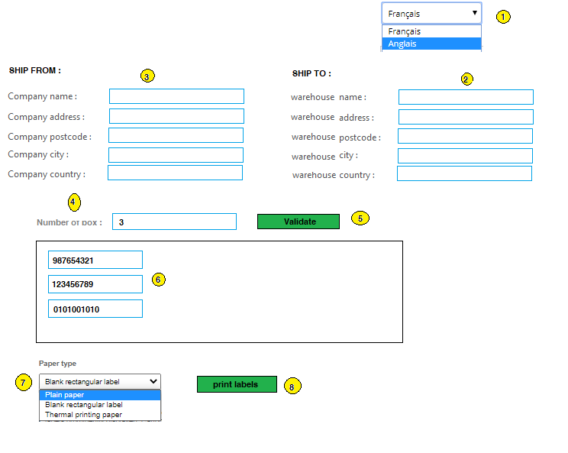

The green button **Validate**, will allow us to define the number of boxes.

The green button **print labels**, will allow us to print labels.

Label  if(lang ==”EN”):

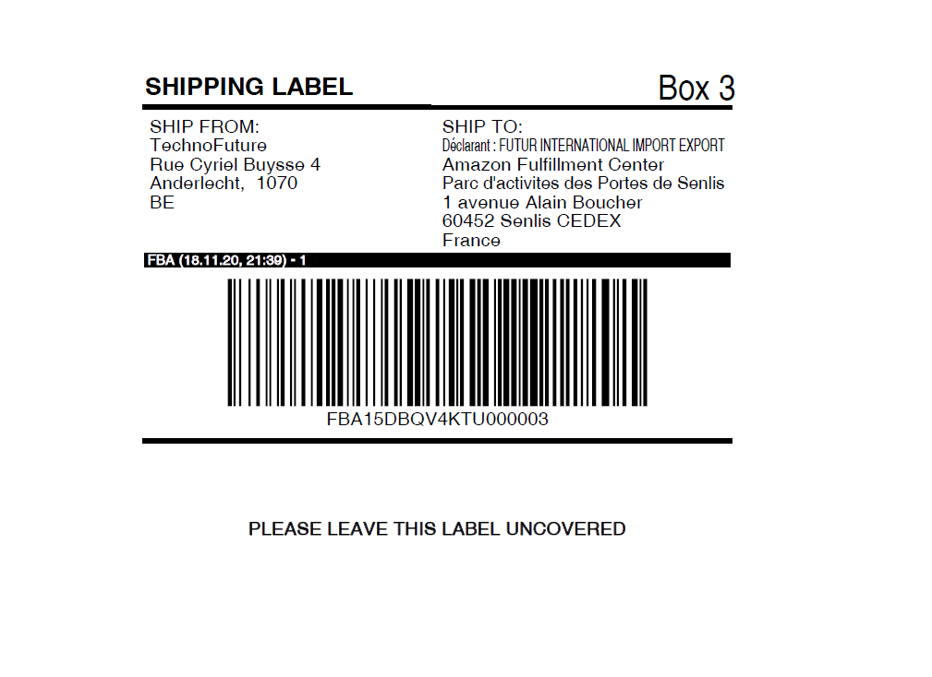

Label  if(lang ==”FR”):

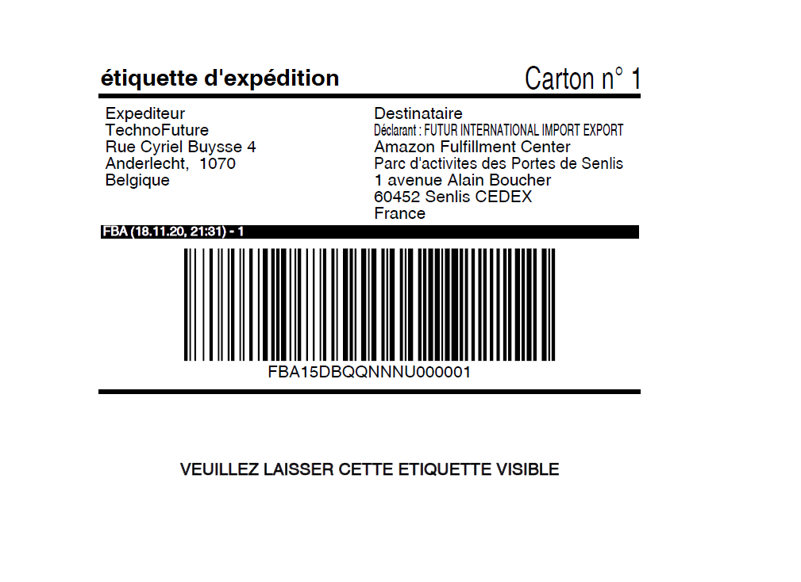

There are some small differences between the two labels FR or EN. in the text, (please see the example above).

**Progress of the operation :**

**1** The customer chooses his language, the information is stored in the session.

**2 and 3** the customer fills in the forms with the sending and receiving address.

**4** The customer specifies the number of boxes he wishes to send.

5 The customer validates the number of packages to validate the number of bar code fields.

**6** The number of barcode fields varies according to the number of boxes.

**7** The customer chooses the PDF format (See the PDF examples in the attachments).

**8** print label.

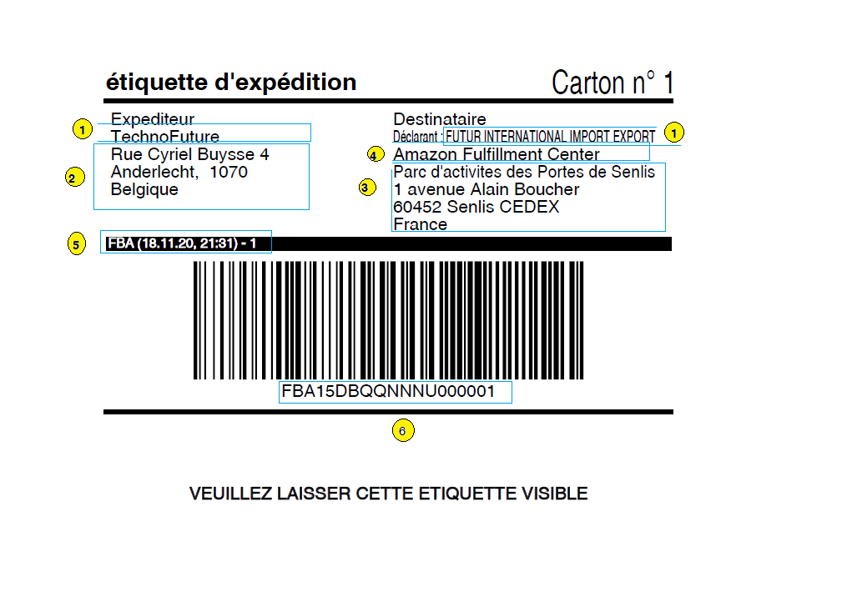

**1 and 1** the same text company_name

**2 :**

* company_address
* company_ postcode
* company_city
* company_ country

**3 :**

* warehouse _address
* warehouse _ postcode
* warehouse _city
* warehouse _ country

**4 :**

* warehouse _name

**5 :** the date of the PDF generation

**6 :** boxe_ barcode